Project FALCON Sensor Power and Visibility Approval List
Printable panel handout for revised compact event driven buoy proposal
Prepared for proposal validation | 11 October 2026 | Prices must be reconfirmed before purchase
This document consolidates the required sensors, power components, and night visibility equipment for the revised Project FALCON compact buoy. The purpose is to help the panel approve what will be reused, what must still be bought, and which optional modules can be deferred. The recommended direction is a low cost ESP32 buoy that samples locally, sends summary packets, and uses solar assisted battery power.
Main recommendation: approve the field ready low cost validation package, but buy in stages. Confirm the water pressure sensor first, then validate the power budget using the ESP32, internet module, GPS, wind sensor, pressure interface, battery, solar panel, and night light current draw.

Recommended approval package
Package | Includes | Estimated equipment cost | Decision
Minimum bench validation | ESP32, pressure interface, simulated inputs, GPS, INA219, Wi-Fi, LEDs/buttons from existing kit | PHP 4,700-7,900 plus existing kit parts | Good for proposal and bench testing
Field ready low cost validation | Core sensors plus battery, solar panel, solar charger/BMS, LTE if needed, marine night beacon, waterproofing, buoy body, chain, anchor | PHP 8,000-16,000+ depending battery, solar and LTE choices | Best approval target
Safer marine option | Better pressure transmitter, industrial wind sensor, LiFePO4 battery, IP68 beacon, better waterproof connectors | PHP 15,000-30,000+ depending quotations | Use only if budget allows

Equipment cards for panel approval
Each card shows the role, the current planning price, where to verify the item, and the approval note. Product pictures are real reference photos from online product listings or product photo sources; the exact SKU and seller must still be checked again before buying.
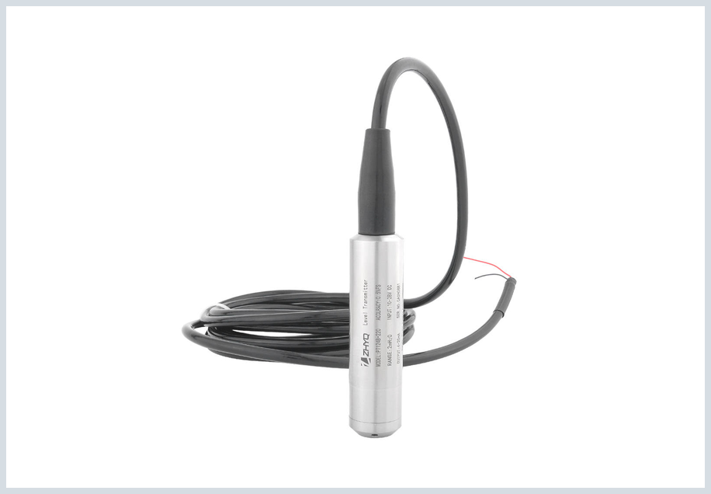 | Water pressure and wave input  Group: Core sensor  Priority: Required  Recommended item: Low-range submersible hydrostatic level transmitter, 4-20 mA preferred, target 0-1 mH2O or 0-2 mH2O  Planning price: PHP 2,897-3,720 typical; lower listings around PHP 1,471 need strict verification  Buy from or verify at: Lazada QDY30A / hydrostatic transmitter listings  Approval note: Approve first. Main research sensor. Avoid high-range pump or automotive pressure sensors unless low-range water-level units cannot be verified.

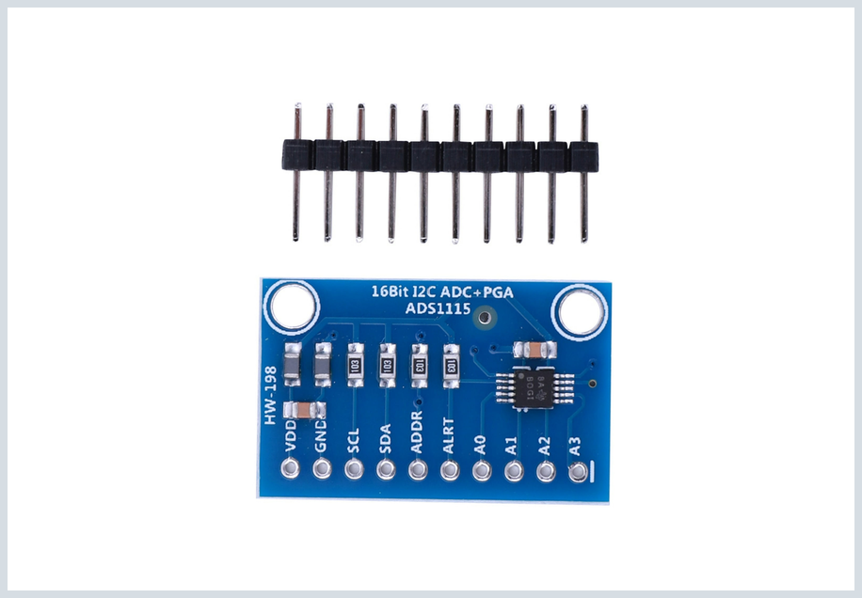 | Pressure signal interface  Group: Interface  Priority: Required interface  Recommended item: ADS1115 16-bit ADC plus 150 ohm precision shunt, RC filter and protection parts  Planning price: PHP 135-290 for ADS1115; add PHP 100-250 for shunt/protection  Buy from or verify at: Lazada ADS1115 module listings  Approval note: Approve with pressure sensor. ESP32 cannot directly read a 4-20 mA loop without interface parts.

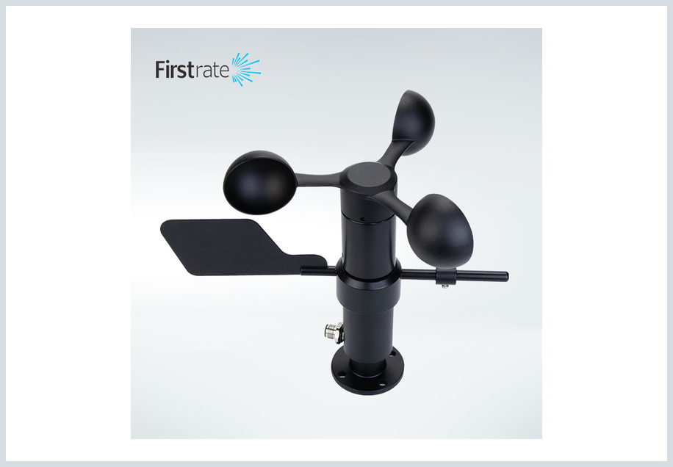 | Wind speed and direction  Group: Core sensor  Priority: Required  Recommended item: Combined cup anemometer plus wind vane, RS485 / 0-5 V / 4-20 mA output preferred  Planning price: PHP 1,204-1,639 low-cost; industrial units PHP 3,666-9,282  Buy from or verify at: Shopee anemometer listings; Lazada industrial anemometer listings  Approval note: Approve low-cost combined speed and direction model first. If only speed is included, buy separate wind vane or mark wind direction as pending.

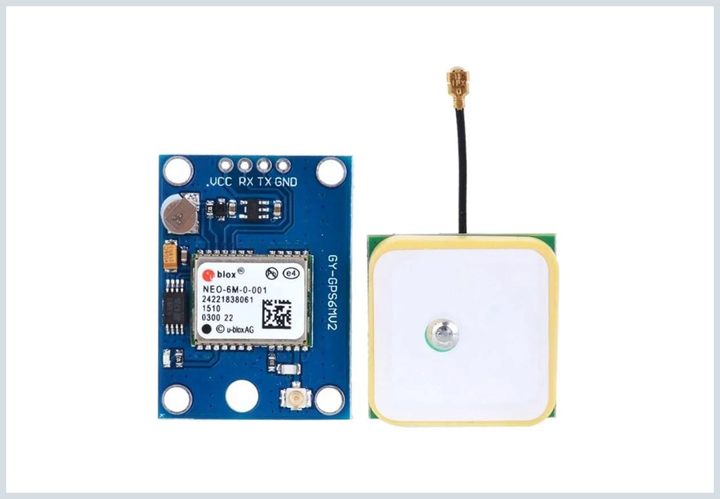 | GPS position and security  Group: Core support  Priority: Required  Recommended item: NEO-6M GPS module with ceramic antenna or equivalent GNSS board  Planning price: PHP 299-497 common; higher listings up to PHP 1,143  Buy from or verify at: MakerLab PH / Lazada NEO-6M GPS listings  Approval note: Approve. Provides exact position, drift/geofence evidence, timestamp support and anti-loss/security proof.

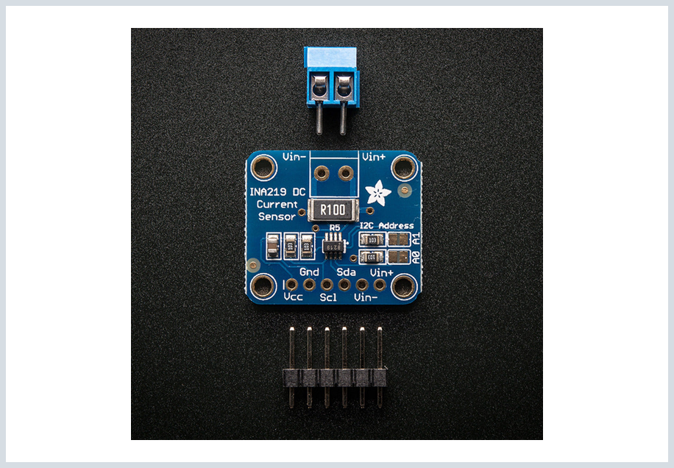 | Battery and solar monitor  Group: Power monitor  Priority: Required support  Recommended item: INA219 current and power monitor module; INA260 as upgrade option  Planning price: PHP 83-180 for INA219; INA260 around PHP 593  Buy from or verify at: Shopee INA219, imBento Cebu, Lazada INA260 tag result  Approval note: Approve INA219 first for low cost. It validates battery voltage, charging behavior, and power budget.

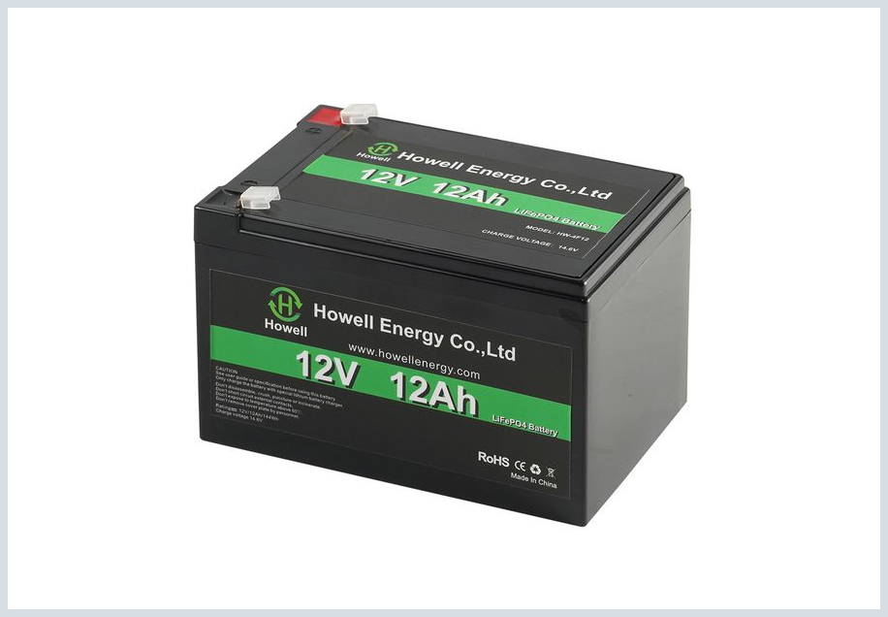 | Rechargeable battery pack  Group: Power system  Priority: Required power  Recommended item: Small 12 V LiFePO4 pack with built-in BMS, or protected 18650 pack for prototype validation  Planning price: Prototype holders/cases from PHP 15-499; small 12 V LiFePO4 planning range PHP 1,500-3,500+  Buy from or verify at: Shopee 18650 holder/BMS listings; Lazada lithium/LiFePO4 battery listings  Approval note: Add to approval list. Battery capacity must be sized after ESP32, LTE, GPS, sensors, and night light current are measured.

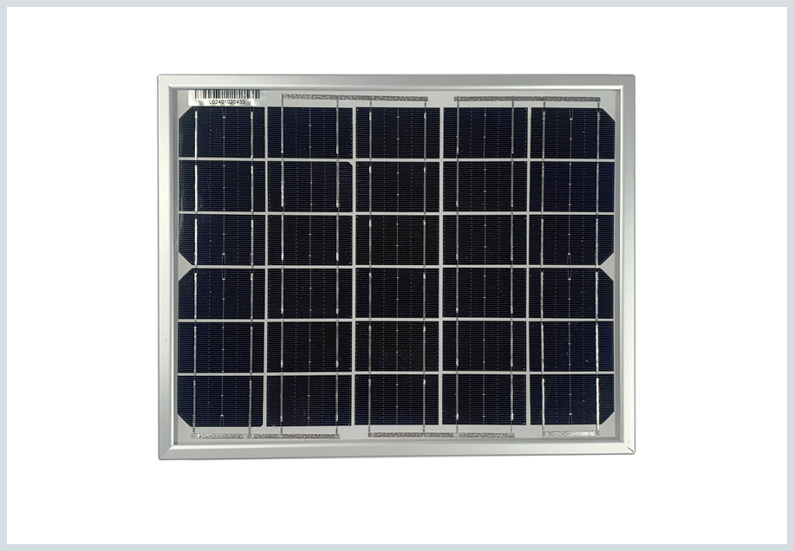 | Solar panel  Group: Power system  Priority: Required power  Recommended item: DIY mini solar panel or small solar cell module, about 3W-10W for the compact buoy; choose 5V, 6V, or 12V based on the final battery and charger design  Planning price: DIY mini solar panels / small solar cell modules are commonly available online around PHP 188-249 for 3W-5W class; larger 12V kits cost more and may be too big for the compact buoy  Buy from or verify at: Shopee/Lazada DIY mini solar panel, 5V/5W, 6V/5W, and small solar cell module listings  Approval note: Add to approval list, but keep it physically small. DIY mini solar panels are acceptable for proposal validation if they are sealed or protected. Final wattage depends on measured daily load, available top-deck area, sun exposure, and whether the night beacon has its own solar panel.

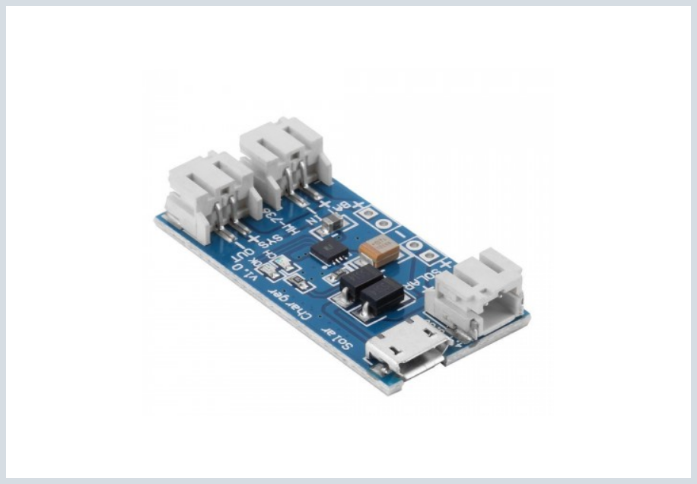 | Solar charger and battery protection  Group: Power system  Priority: Required power interface  Recommended item: Solar charge controller matched to battery chemistry; include BMS for lithium/LiFePO4 packs  Planning price: Small PWM controllers around PHP 189; CN3065/TP4056 class modules lower cost for single-cell prototypes  Buy from or verify at: Shopee solar charge controller listings; CN3065/TP4056 module references  Approval note: Required if solar charging is used. Do not connect solar panel directly to lithium battery without proper charger and protection.

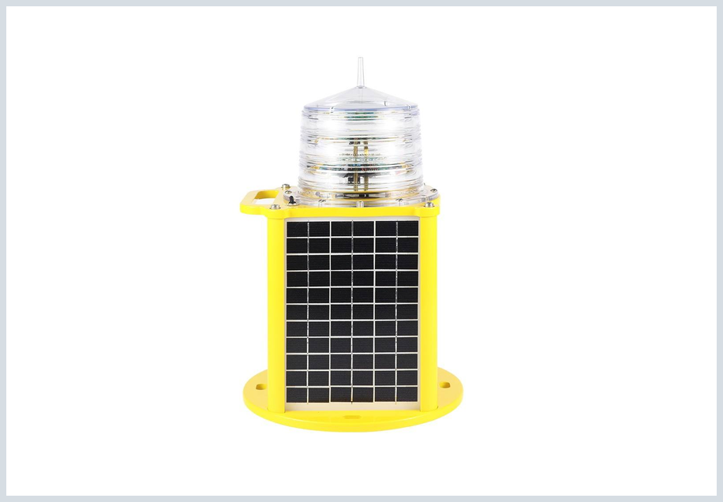 | Marine night light or beacon  Group: Safety  Priority: Required visibility/safety  Recommended item: Waterproof solar marine beacon / buoy signal light, IP66-IP68 preferred, visible at night  Planning price: Lazada/Shopee marine signal lights around PHP 269-781 for low-cost units; better marine lanterns cost more  Buy from or verify at: Shopee solar marine navigation light; Lazada boat signal / solar beacon listings  Approval note: Add for night visibility and safety. Prefer a self-contained solar beacon so it does not drain the main electronics battery.

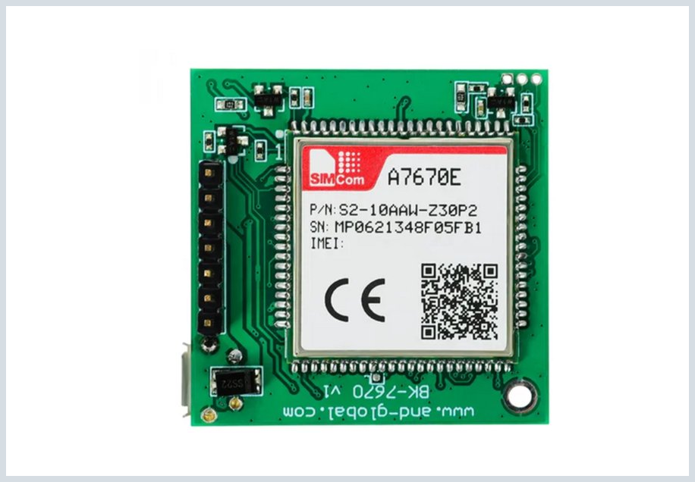 | Internet module  Group: Communication  Priority: Conditional communication  Recommended item: ESP32 Wi-Fi for lab; A7670E LTE Cat-1 or Waveshare ESP32-S3 A7670E for field  Planning price: A7670E core PHP 1,015-1,151; Waveshare ESP32-S3 A7670E PHP 2,614; T-SIM7600 class PHP 4,192  Buy from or verify at: Lazada A7670E / ESP32 SIM LTE listings  Approval note: Keep as conditional. Use Wi-Fi for bench and near-shore tests; buy LTE only when the site has no stable Wi-Fi.

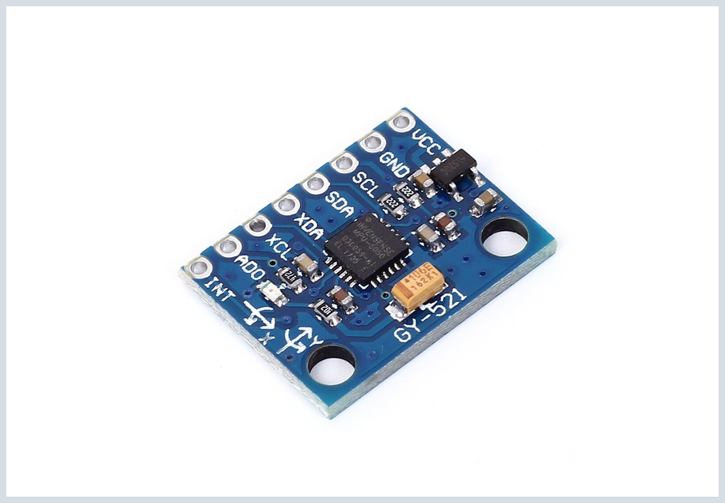 | Tilt and motion  Group: Optional  Priority: Optional event/security  Recommended item: MPU6050 / GY-521 accelerometer and gyroscope module  Planning price: PHP 92-223 typical  Buy from or verify at: Lazada MPU6050 listings  Approval note: Optional. Adds movement or tilt event trigger. It does not replace the water pressure sensor.

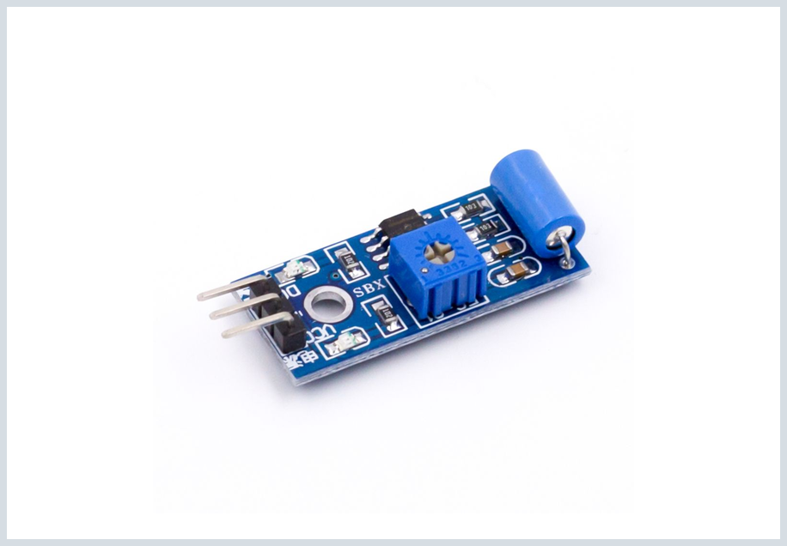 | Vibration and tamper  Group: Optional  Priority: Optional event/security  Recommended item: SW-420 vibration sensor module  Planning price: PHP 45-70 typical  Buy from or verify at: e-Gizmo, MakerLab, Lazada sensor module tag results  Approval note: Optional. Good for enclosure hit or tamper trigger; not reliable as wave measurement.

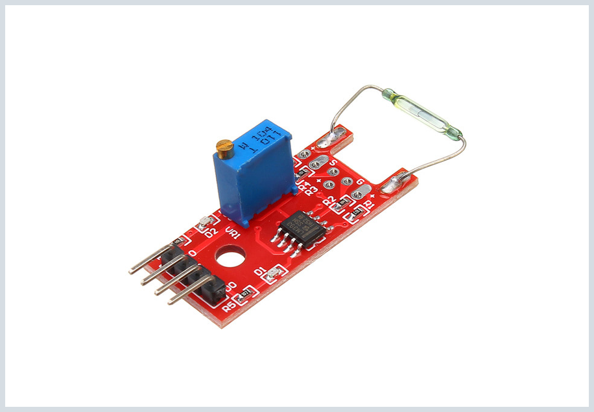 | Lid-open tamper  Group: Optional  Priority: Optional event/security  Recommended item: Reed switch or magnetic switch module  Planning price: PHP 70-309 depending style  Buy from or verify at: Lazada magnetic switch; local hobby electronics reed switch modules  Approval note: Optional. Good for detecting if the enclosure is opened during field display or validation.

Alternatives and items not recommended as replacements
Channel | Lower cost option | Better or safer option | Do not approve as replacement
Water pressure | Generic low-range 4-20 mA hydrostatic transmitter | Holykell HPT604 Type A or equivalent quoted industrial unit; RS485 Modbus if cable noise becomes a problem | Float switch, rain sensor, HC-SR04 ultrasonic sensor, automotive oil or fuel pressure sensor
Wind | Low-cost combined cup sensor and vane | Industrial RS485 combined sensor with IP65 or IP66 housing | Handheld anemometer or toy wind vane as final installed sensor
Power | Protected 18650 pack for bench validation | 12 V LiFePO4 pack with BMS and measured capacity | Loose cells with no BMS, no fuse, or no waterproof enclosure
Solar charging | Small solar charger module matched to the DIY panel and battery | Battery chemistry matched solar charger or MPPT controller | Direct solar panel to lithium battery connection
Night visibility | DIY mini solar panel / small solar cell module | IP66-IP68 marine beacon or self-contained solar buoy light | Indoor LED strip, flashlight, or non-waterproof decorative light
Internet | ESP32 Wi-Fi for lab | A7670E LTE Cat-1 or SIM7600 class board for field | Always-on every-second upload
Motion and tamper | SW-420 or reed switch | MPU6050 plus enclosure reed switch | Motion sensor as replacement for pressure sensor

Approval buying order
- Use the existing ESP32 kit, breadboard, jumper wires, buttons, LEDs, and buck converters for bench validation only.
- Buy or confirm the water pressure sensor and pressure interface first because this is the core measurement path.
- Add GPS, INA219, and wind speed/direction after the pressure path is defined.
- Measure ESP32, GPS, LTE/Wi-Fi, wind sensor, pressure interface, and beacon current before final battery sizing.
- Choose the battery pack with BMS, matching solar charge controller, and solar panel after the load estimate is measured.
- Use a self-contained solar marine beacon if possible so night visibility does not drain the main electronics battery.
- Buy LTE only if the validation site has no reliable Wi-Fi. Keep LoRa as fallback only.

Source references for price checking
Prices and availability can change. These links are included so the group can re-check the current seller page before purchase.
- Pressure transmitter QDY30A listing: https://www.lazada.com.ph/videodetail/?video_id=8000144764410
- Pressure transmitter 1 m 3 m 5 m listing: https://www.lazada.com.ph/videodetail/?video_id=8000146168991
- Water level sensor tag result: https://www.lazada.com.ph/tag/tank-level-monitoring-system/
- ADS1115 listing: https://www.lazada.com.ph/videodetail/?video_id=8000078224372
- Shopee anemometer search: https://shopee.ph/list/anemometer
- MakerLab Shopee anemometer listing: https://shopee.ph/Anemometer-Wind-Speed-Sensor-0-to-5V-Analog-RS485-i.18252381.40953188107
- NEO-6M GPS listing: https://www.lazada.com.ph/videodetail/?video_id=8000133608045
- Shopee INA219 listing: https://shopee.ph/INA219-GY-219-I2C-Bi-directional-DC-Current-Power-Supply-Sensor-Breakout-Module-for-Arduino-DIY-i.1063532622.25639962980
- imBento INA219 listing: https://imbento.com/shop/product/439
- 18650 battery holder search: https://shopee.ph/list/18650%20battery%20holder
- BeMuchSafer battery/BMS store: https://shopee.ph/bemuchsafer.ph
- Shopee 12 V solar panel search: https://shopee.ph/list/12v%20solar%20panel
- Lazada 10 W 12 V solar panel tag: https://www.lazada.com.ph/tag/solar-panel-10w-12v/
- Solar marine navigation light listing: https://shopee.ph/love%2A-Solar-Powered-Marine-Navigation-Light-Waterproof-IP68-for-Fishing-Net-Buoys-i.135511368.51962091672
- Lazada boat signal light tag: https://www.lazada.com.ph/tag/boatsignal-light-led/
- A7670E listings: https://www.lazada.com.ph/tag/a7670e/
- ESP32 LTE listings: https://www.lazada.com.ph/tag/esp32-sim/
- MPU6050 listing: https://www.lazada.com.ph/videodetail/?video_id=8000145952787
- SW-420 e-Gizmo: https://e-gizmo.net/gizmoshop/index.php?product_id=1611&route=product%2Fproduct
- SW-420 MakerLab: https://makerlab.ph/products/vibration-sensor-sw-420
- Magnetic switch listing: https://www.lazada.com.ph/videodetail/?video_id=8000131458280
- 5V/5W small solar panel listing: https://shopee.ph/GOLDEN-5V-5W-Small-Solar-Panel-With-USB-DIY-Monocrystalline-Silicon-Solar-Cell-Waterproof-Portable-Camping-Power-Panel-For-Mobile-Phone-PH-i.206104448.47456957544
- Small solar panel search: https://shopee.ph/list/small%20solar%20panel
- 6V/5W solar panel tag: https://www.lazada.com.ph/tag/6v-5w-solar-panel/
- DIY solar panel search: https://shopee.ph/list/diy%20solar%20panel
- Small solar cell module search: https://shopee.ph/list/small%20solar%20cell

